- Instructions for android devices.

- (may differ for other devices)

- ***please make sure are connected to Wi-Fi as data charges may apply***

- On your device go to google play store

- Download overdrive app (make sure the icon looks like this)

- 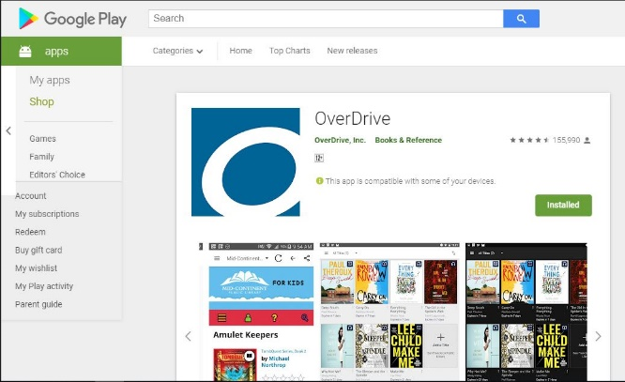
- Install the app

- Restart your device

- Open the app

- Click already have an account
- 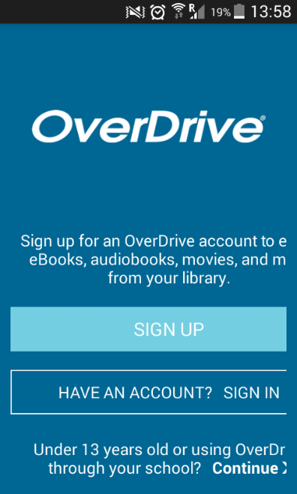

- Find your library
- 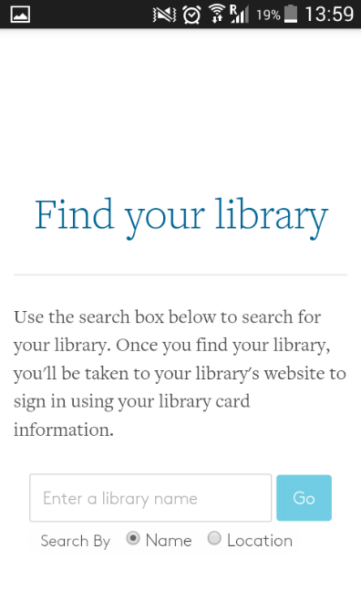
- Search South African Library For The Blind
- 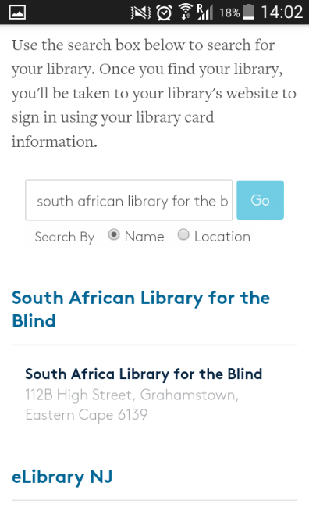
- Click on South African Library For The Blind

- Sign in using your details.

- 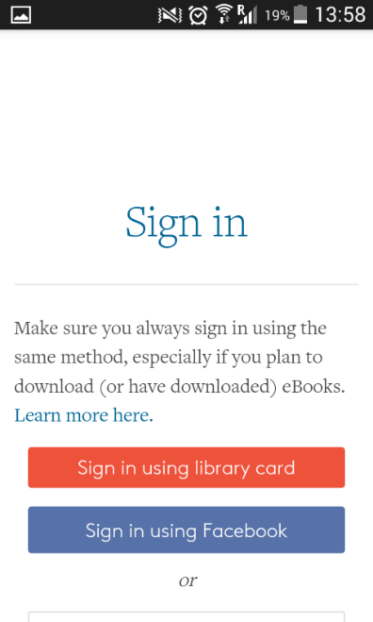

Example of member details
User Barcode 0000xxxx
Password zzzzzz
(the password is case sensitive)

- Click remember me on this device
- 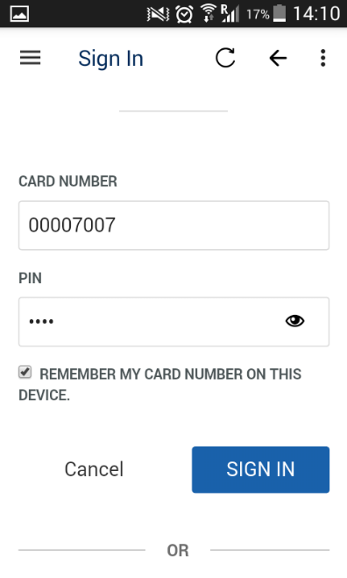
- Once signed in

- Click on the three horizontal stripes on the right

- Click on collections

- 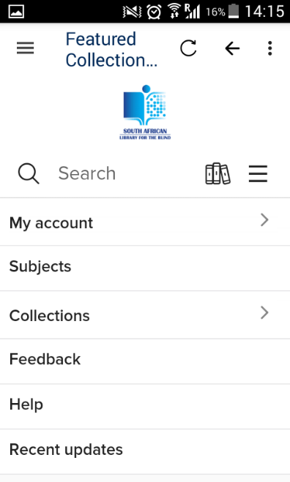

- Browse to audiobook collection

- 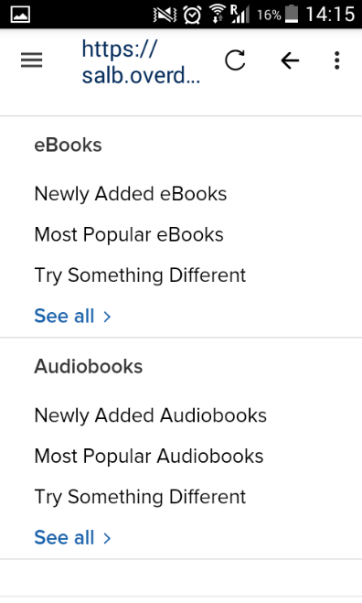

- Click see all to browse audiobooks

- Select a book to borrow

- 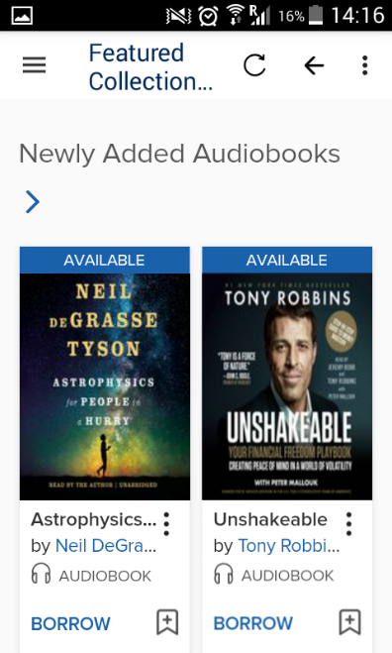
- Select how long you want to borrow it for 14 or 21 days
- Click borrow

- 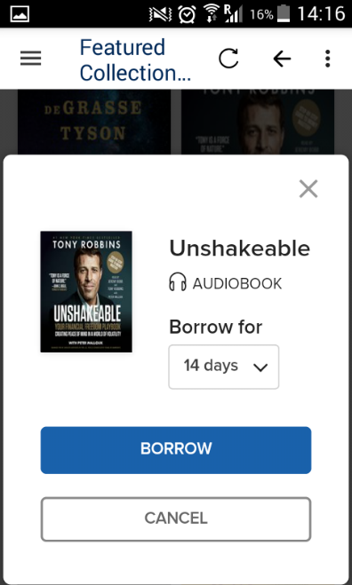
- **you can only borrow two books at a time, but may return books early to borrow more books**

- Click download mp3 audiobook

- 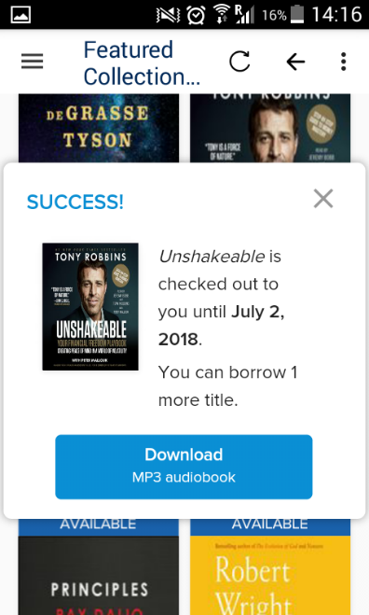
- The book will start downloading

- 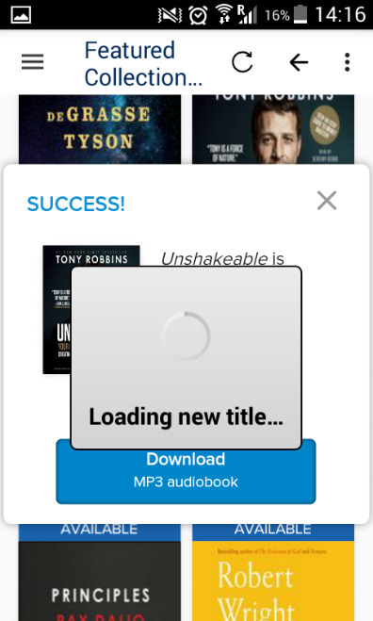

- Click on the three horizontal stripes on the left

- Go down to files to check progress of the download
- 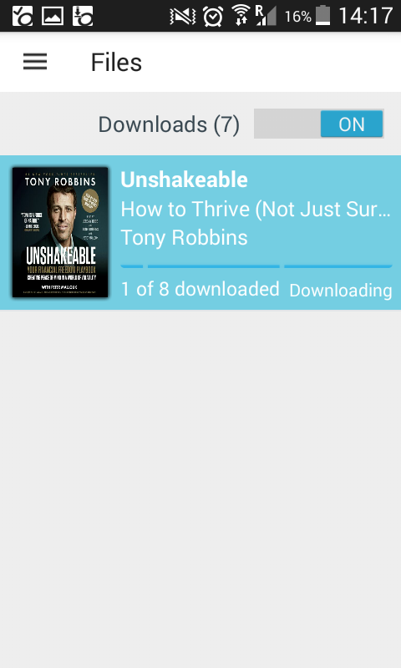

- Go to bookshelf once all the files have downloaded

- 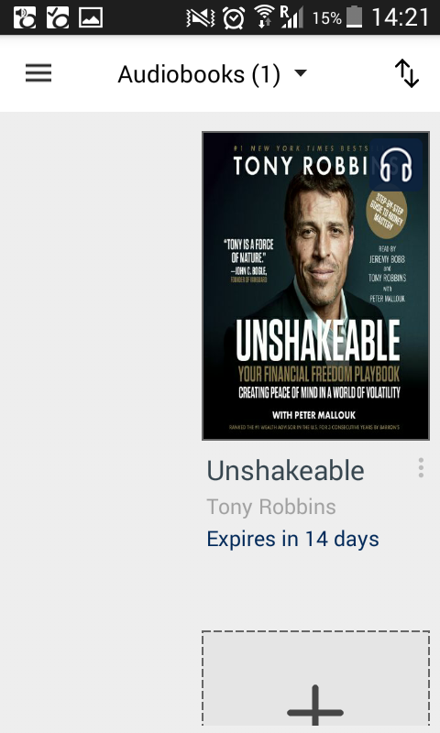
- Click on your audiobook and start listening

- 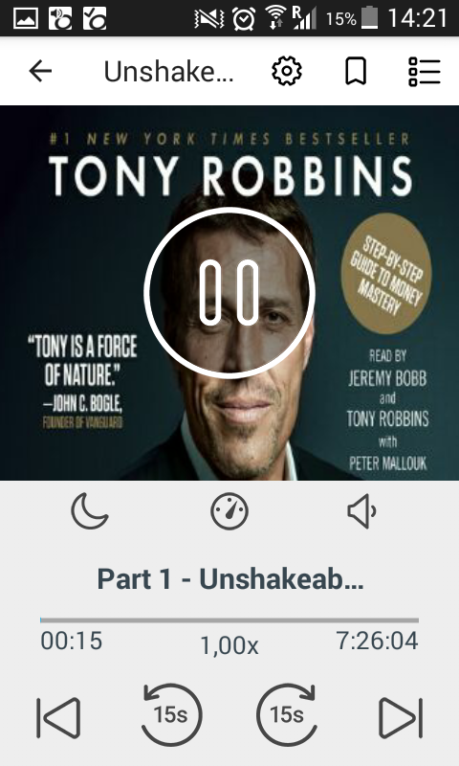

- To return a book

- Go to bookshelf

- Click on the three dots (one above the other) next to the book title

- Select return to library

